**Deliverable 2 Report**

Team Assignments:

Wai Fong – MaintainabilityIndexTest

Shrunga Malavalli – LoopingStatementCounterTest

Linh Nguyen – MethodCounterTest, MethodCounterIntegrationTest, LoopingCounterIntegrationTest

Carly Ott – HalsteadMetricsTest

Kimi Phan – CastCounterTest, ExpressionCounterTest, CastCounterIntegrationTest, ExpressionCounterIntegrationTest

Kayla Rhodes – CommentCounterTest, VariableCounterTest, DriverCode for integration tests, CommentCounterIntegrationTest, VariableCounterIntegrationTest

**Testing Framework and Strategy**

The testing framework that we chose was top down integration testing.

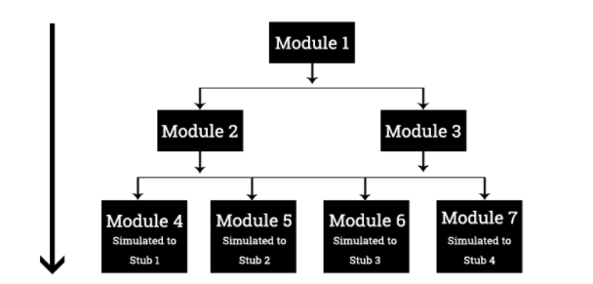

We picked this testing process as it seemed the most reasonable for testing this project. In the second deliverable, we first started to test the overall code and then started testing individual components. The order that we tested our components depended on if there were dependencies. We first tested the variable counter, comment counter, cast counter, expression counter, looping counter, and the method counter because they did not depend on any other classes expect for the eclipse checkstyle class. This would be first level in the call graph. The second level of the call graph would be the Halsted Metrics class because it depends on the expression counter. The third level of the call graph would be the Maintainability Index class because it depends on the comment counter and the Halsted Metrics.

**Bugs discovered during un Bugs discovered during unit testing:**

MaintainabilityIndex

* In setMaintainabilityIndex(), required casting double when getting cm.
* Removed “final” from getRequiredTokens() in MaintainabilityIndex, CyclomaticComplexity, and ExecutableStatementCount because it was causing issues to JUint.

ExpressionCounter

* While testing the expressionCounter I found out that I had the token LE was in my program twice, so when I was testing each token the uniqueOperators was not incrementing correctly.
* I also found out that I was missing the operator STAR.

**Bugs discovered during integration testing:**

There were no bugs found during integration testing.

**Deliverable 2 Schedule**

Unit Testing 🡪 Due Thursday, October 18th

Integration Testing 🡪 Due Thursday, October 25th

Talk to Cai on October 26th 🡪 have him review our tests, make any need changes over the weekend

Document bugs found throughout testing process

Complete bug report between October 26th and October 28th

Google doc for report